MOVIE SUCCESS PREDICTOR
WEEK 2 – DATA CLEANING REPORT
Dataset: IMDb 5000 Movie Dataset

1. Introduction
Data cleaning is an important stage of the Movie Success Predictor project. The objective of this stage is to improve the quality and reliability of the IMDb 5000 Movie Dataset before performing Exploratory Data Analysis (EDA). The original dataset contains 5,043 movie records and 28 attributes. The work completed in Week 2 included removing unnecessary columns, handling missing values, detecting outliers, and identifying duplicate records.

2. Removal of Unnecessary Attributes
Five attributes were removed because they were not required for the planned pre-release gross revenue prediction. These attributes contain a URL, an IMDb score, or audience and critic activity that is generally known only after a movie has been released.
Removed attribute | Reason
movie_imdb_link | IMDb webpage URL; not a direct prediction feature.
imdb_score | Not required for gross revenue prediction and may not be available pre-release.
num_voted_users | Represents post-release audience activity.
num_user_for_reviews | Represents post-release user review activity.
num_critic_for_reviews | Generally reflects post-release critic review activity.
After removing these five attributes, the dataset contained 5,043 rows and 23 columns.

3. Missing Value Handling
The dataset contained missing values in several numerical and categorical attributes. Median imputation was applied to numerical predictor columns because the median is less affected by extreme values. Mode imputation was applied to categorical columns by replacing missing entries with the most frequent category. The target attribute, gross, was intentionally left missing where no revenue value was available. Those rows will be excluded when preparing the supervised regression dataset.
Figure 1 shows the pattern of missing values across the dataset. The gross column has the densest concentration of missing entries, followed by budget, aspect_ratio, content_rating, and plot_keywords, while most other attributes are largely complete.
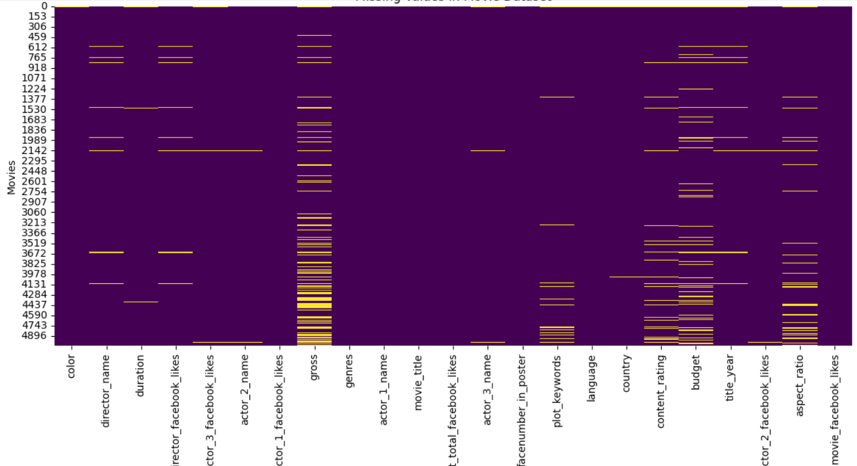
Figure 1. Missing values in the movie dataset (yellow = missing).

4. Outlier Detection Using IQR
Outliers were examined in budget, gross revenue, and duration using the Interquartile Range (IQR) method. IQR is calculated as Q3 − Q1. The lower and upper limits are Q1 − 1.5 × IQR and Q3 + 1.5 × IQR, respectively. Boxplots of the three attributes are shown in Figure 2.
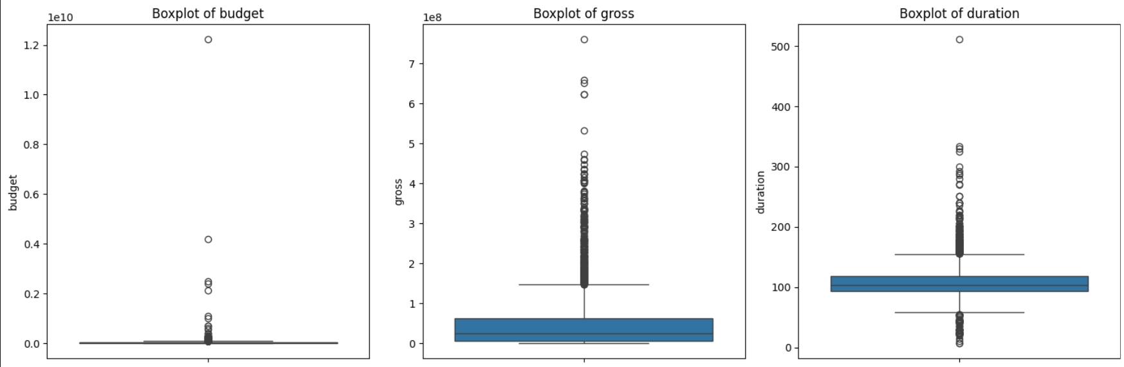
Figure 2. Boxplots of budget, gross revenue, and duration used for IQR outlier inspection.
Budget shows a few extreme values far above the main body of the data, gross revenue has a long upper tail of high-earning films, and duration has outliers on both the short and long side.
The detected outliers were not automatically removed. Very high budgets and gross revenues may represent genuine large-scale productions or successful blockbuster movies. The values were therefore retained for further investigation rather than deleted solely because they fall outside the IQR limits.

5. Duplicate Record Analysis
The duplicated() function in Pandas was used to identify repeated rows. The original dataset contained 45 duplicate records. These records were identified but retained during this stage, pending further verification.

6. Cleaning Summary
Parameter | Before cleaning | After Week 2
Rows | 5,043 | 5,043
Attributes | 28 | 23
Missing predictor values | Present | Numerical/categorical imputation applied
Missing gross values | Present | Retained
Outliers | Not evaluated | Detected using IQR; retained
Duplicate rows | 45 | 45 retained

7. Conclusion
During Week 2, the IMDb 5000 Movie Dataset underwent an initial data cleaning process. Five unnecessary attributes were removed, missing predictor values were handled using median and mode imputation, and outliers were identified using the IQR method. Duplicate records were also identified and retained for verification. The cleaned dataset is now prepared for the next project stage: Exploratory Data Analysis (EDA). For final model development, preprocessing steps such as imputation should be fitted using training data only to avoid data leakage.

